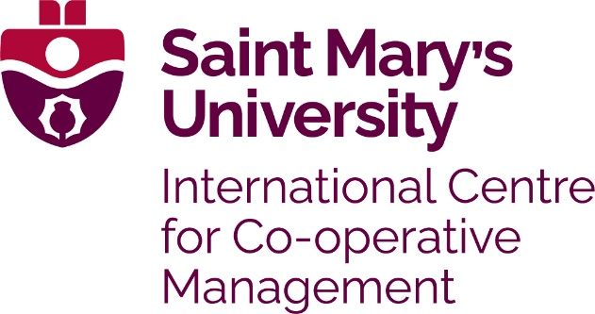

The International Centre for Co-operative Management (ICCM) at Saint Mary’s University has bursaries available to graduate students enrolled in their Master’s or Graduate Diploma programs. These annual awards will be directed to graduate students who demonstrate financial need. Additional bursary criteria are outlined below.

Dr. Sidney Pobihushchy Bursary
Established through the generosity of members of the Co-operative Management Education Co-operative (CMEC) and supporters of the Master of Management, Co-operatives and Credit Unions (MMCCU) program, the bursary was named in Honor of the late Dr. Sidney I Pobihushchy in 2007. Dr. Pobihushchy was a long time promoter of co-operative education, held undergraduate and honorary degrees from Saint Mary’s University, and was co-founder of the Co-operative Management Education program. Variable amounts are awarded based on applicant need and availability of funds on any given year.

Leadership in Co-operative Management Education Bursary
Through the generosity and support of the Co-operative Management Education Co-operative (CMEC), a bursary was established in 2014. There are designated funds within this bursary that support each Canadian, US and international applicants from co-operative organizations who might not otherwise be able to afford the program costs. Variable amounts are awarded based on applicant need and availability of funds on any given year. Thank you to the ongoing supporters including The Co-operators as well as Centre’s staff members, individual donors and alumni.

Carmel Bellamy Co-op Governance Bursary
The fund was established in 2024 to commemorate the life and achievements of Carmel Bellamy, a 42-year employee of The Co-operators Group Limited, ultimately the Vice-President, Corporate Secretary and Director of Corporate Governance who passed away suddenly in 2023. Ms. Bellamy began working for The Co-operators just out of high school and through innate abilities, hard work and dedication learned about the co-operative model and finished her
career at the top of her profession as well as at a Senior Position in Co-operator’s management. She was also elected to the Board of Directors of Governance Professionals of Canada. The Carmel Bellamy Co-op Governance Bursary will be awarded annually to recipient(s) enrolled in any co-operative governance programming or undertaking research through the Saint Mary’s University International Centre for Co-operative Management. Preference will be given to recipients who might not otherwise be able to afford the program costs including recipients from traditionally
under-represented groups or communities. This bursary is non-renewable although an individual may be selected to receive it more than once.

These awards are non-renewable; however, applicants may reapply each year.
Application deadline is May 31st
Note that only applicants with complete degree program applications will be considered for a bursary.

Contact Information:
Name (and pronouns if you choose):
Organization: |  | Title:
Address:
City: | Province/State:
Country: | Postal/Zip Code:
Telephone Number: | Email:

In 500 words or less, please:
1) Describe your need for financial assistance and
2) Include the amount of funding you are requesting
Do you have a particular role related to or passion for co-operative governance? Please describe your relevant co-operative governance experience, background and interests. Please note: Only some of our bursary funds are required to be allocated to individuals with an interest in co-operative governance. Therefore, it is not necessary that you fill out this section (max 300 words):

ICCM Bursary awards are limited – full scholarships are not available. To help us determine your eligibility, please indicate other sources of funding you will rely on to cover program costs (other scholarships/bursaries you have applied for/received, amount of financial support from your co-operative, self-funding, etc.):

#1 | Amount $
#2 | Amount $
#3 | Amount $
#4 | Amount $
#5 | Amount $

Signature of Applicant: Date:

The application form may be completed and returned electronically to jillian.stagg@smu.ca

